Ekspor Manufaktur(log) vs Impor manufaktur(log)+Impor Service(log) versi1

> ekspor1<-ardl(exM~imM+imSev,data=dat,order = c(3,4,4))

> summary(ekspor1)

Time series regression with "ts" data:

Start = 5, End = 19

Call:

dynlm::dynlm(formula = full_formula, data = data, start = start,

end = end)

Residuals:

5 6 7 8 9 10 11 12

0.0004972 -0.0003975 -0.0009263 0.0004516 0.0009391 -0.0003538 0.0009276 -0.0029040

13 14 15 16 17 18 19

0.0019411 0.0014731 -0.0037828 0.0021294 -0.0002088 0.0006874 -0.0004733

Coefficients:

Estimate Std. Error t value Pr(>|t|)

(Intercept) -1.13894 0.75145 -1.516 0.3713

L(exM, 1) 0.48345 0.13947 3.466 0.1788

L(exM, 2) 0.20977 0.14648 1.432 0.3881

L(exM, 3) 0.05407 0.16548 0.327 0.7989

imM 0.78075 0.08554 9.127 0.0695 .

L(imM, 1) 0.07350 0.07938 0.926 0.5245

L(imM, 2) -0.28738 0.09169 -3.134 0.1966

L(imM, 3) -0.42148 0.09148 -4.607 0.1361

L(imM, 4) 0.25777 0.13857 1.860 0.3140

imSev -0.26231 0.07445 -3.523 0.1761

L(imSev, 1) -0.15982 0.07079 -2.258 0.2654

L(imSev, 2) 0.07282 0.10469 0.696 0.6131

L(imSev, 3) 1.10405 0.26630 4.146 0.1507

L(imSev, 4) -0.67688 0.25584 -2.646 0.2301

---

Signif. codes: 0 ‘***’ 0.001 ‘**’ 0.01 ‘*’ 0.05 ‘.’ 0.1 ‘ ’ 1

Residual standard error: 0.006107 on 1 degrees of freedom

Multiple R-squared: 0.9997, Adjusted R-squared: 0.9964

F-statistic: 297.1 on 13 and 1 DF, p-value: 0.04538

Ekspor Manufaktur(log) vs Impor manufaktur(log)+Impor Service(log) versi2

> ekspor2<-ardl(exM~imM+imSev,data=dat,order = c(1,0,0))

> summary(ekspor2)

Time series regression with "ts" data:

Start = 2, End = 19

Call:

dynlm::dynlm(formula = full_formula, data = data, start = start,

end = end)

Residuals:

Min 1Q Median 3Q Max

-0.06575 -0.02401 -0.01109 0.02547 0.08901

Coefficients:

Estimate Std. Error t value Pr(>|t|)

(Intercept) 0.7041 0.7245 0.972 0.34765

L(exM, 1) 0.6764 0.2220 3.047 0.00871 **

imM 0.2730 0.1837 1.486 0.15952

imSev -0.1060 0.2468 -0.429 0.67416

---

Signif. codes: 0 ‘***’ 0.001 ‘**’ 0.01 ‘*’ 0.05 ‘.’ 0.1 ‘ ’ 1

Residual standard error: 0.04563 on 14 degrees of freedom

Multiple R-squared: 0.8812, Adjusted R-squared: 0.8557

F-statistic: 34.61 on 3 and 14 DF, p-value: 9.934e-07

Ekspor Manufaktur(log) vs Impor manufaktur(log)+Impor Service(log) versi3

> ekspor3<-ardl(exM~imM+imSev,data=dat,order = c(1,1,1))

> summary(ekspor3)

Time series regression with "ts" data:

Start = 2, End = 19

Call:

dynlm::dynlm(formula = full_formula, data = data, start = start,

end = end)

Residuals:

Min 1Q Median 3Q Max

-0.038164 -0.010518 0.004179 0.017573 0.030152

Coefficients:

Estimate Std. Error t value Pr(>|t|)

(Intercept) 1.3536 0.6922 1.956 0.0742 .

L(exM, 1) 1.1353 0.1772 6.406 3.37e-05 ***

imM 0.3068 0.1273 2.409 0.0330 *

L(imM, 1) -0.1515 0.1664 -0.910 0.3807

imSev -0.1298 0.1455 -0.892 0.3901

L(imSev, 1) -0.4855 0.1820 -2.667 0.0205 *

---

Signif. codes: 0 ‘***’ 0.001 ‘**’ 0.01 ‘*’ 0.05 ‘.’ 0.1 ‘ ’ 1

Residual standard error: 0.02604 on 12 degrees of freedom

Multiple R-squared: 0.9668, Adjusted R-squared: 0.953

F-statistic: 69.94 on 5 and 12 DF, p-value: 1.872e-08

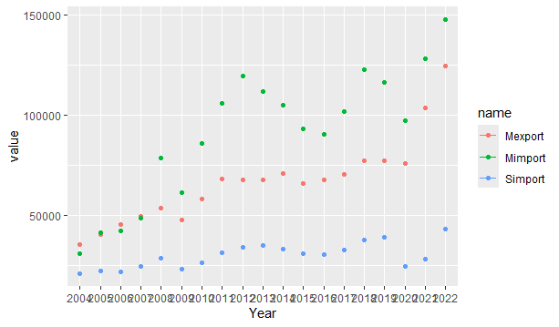

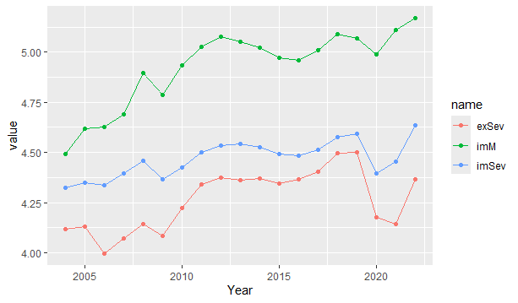

PDB(log) vs Impor manufaktur(log)+Impor Service(log) versi1

> pdb1<-ardl(pdb~imM+imSev,data=dat,order = c(1,0,0))

> summary(pdb1)

Time series regression with "ts" data:

Start = 2, End = 19

Call:

dynlm::dynlm(formula = full_formula, data = data, start = start,

end = end)

Residuals:

Min 1Q Median 3Q Max

-0.0112337 -0.0021912 0.0001196 0.0030936 0.0094824

Coefficients:

Estimate Std. Error t value Pr(>|t|)

(Intercept) 0.112184 0.126733 0.885 0.39100

L(pdb, 1) 0.917288 0.024195 37.913 1.63e-15 ***

imM -0.003365 0.020044 -0.168 0.86907

imSev 0.097575 0.029127 3.350 0.00476 **

---

Signif. codes: 0 ‘***’ 0.001 ‘**’ 0.01 ‘*’ 0.05 ‘.’ 0.1 ‘ ’ 1

Residual standard error: 0.005366 on 14 degrees of freedom

Multiple R-squared: 0.9973, Adjusted R-squared: 0.9967

F-statistic: 1710 on 3 and 14 DF, p-value: < 2.2e-16

PDB(log) vs Impor manufaktur(log)+Impor Service(log) versi2

> pdb2<-ardl(pdb~imM+imSev,data=dat,order = c(1,1,1))

> summary(pdb2)

Time series regression with "ts" data:

Start = 2, End = 19

Call:

dynlm::dynlm(formula = full_formula, data = data, start = start,

end = end)

Residuals:

Min 1Q Median 3Q Max

-0.0071809 -0.0026923 0.0009308 0.0026243 0.0048447

Coefficients:

Estimate Std. Error t value Pr(>|t|)

(Intercept) 0.24263 0.12795 1.896 0.082251 .

L(pdb, 1) 0.93824 0.02212 42.425 1.91e-14 ***

imM -0.02326 0.02201 -1.057 0.311544

L(imM, 1) 0.03126 0.02269 1.378 0.193370

imSev 0.10953 0.02386 4.590 0.000622 ***

L(imSev, 1) -0.08289 0.02963 -2.798 0.016111 *

---

Signif. codes: 0 ‘***’ 0.001 ‘**’ 0.01 ‘*’ 0.05 ‘.’ 0.1 ‘ ’ 1

Residual standard error: 0.004326 on 12 degrees of freedom

Multiple R-squared: 0.9985, Adjusted R-squared: 0.9979

F-statistic: 1580 on 5 and 12 DF, p-value: < 2.2e-16

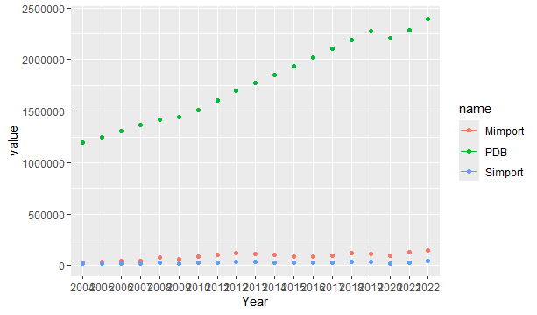

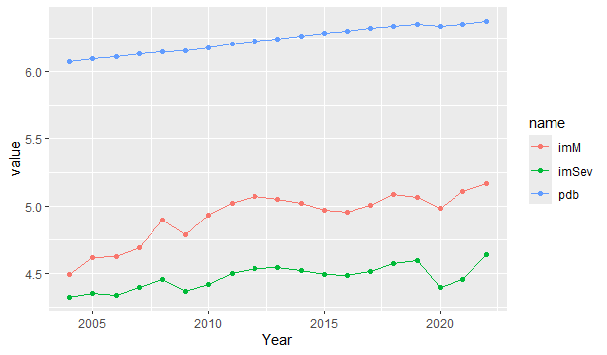

PDB(log) vs Impor manufaktur(log)+Impor Service(log) versi3

> pdb3<-ardl(pdb~imM+imSev,data=dat,order = c(3,4,4))

> summary(pdb3)

Time series regression with "ts" data:

Start = 5, End = 19

Call:

dynlm::dynlm(formula = full_formula, data = data, start = start,

end = end)

Residuals:

5 6 7 8 9 10 11 12

-9.028e-04 2.282e-04 6.913e-04 5.666e-04 -4.128e-04 -4.673e-04 4.412e-04 -6.644e-05

13 14 15 16 17 18 19

-1.220e-03 1.146e-03 8.306e-04 -9.164e-05 -3.085e-05 -3.860e-04 -3.259e-04

Coefficients:

Estimate Std. Error t value Pr(>|t|)

(Intercept) -1.14352 0.88869 -1.287 0.421

L(pdb, 1) 1.09000 0.81084 1.344 0.407

L(pdb, 2) 0.53893 1.01394 0.532 0.689

L(pdb, 3) -0.91223 0.69699 -1.309 0.415

imM 0.02349 0.07620 0.308 0.810

L(imM, 1) 0.11603 0.06935 1.673 0.343

L(imM, 2) -0.01194 0.10512 -0.114 0.928

L(imM, 3) -0.15093 0.12763 -1.183 0.447

L(imM, 4) -0.10503 0.10249 -1.025 0.492

imSev 0.13708 0.04232 3.239 0.191

L(imSev, 1) -0.09719 0.07637 -1.273 0.424

L(imSev, 2) 0.13210 0.17249 0.766 0.584

L(imSev, 3) 0.34379 0.26861 1.280 0.422

L(imSev, 4) 0.27412 0.20122 1.362 0.403

Residual standard error: 0.002452 on 1 degrees of freedom

Multiple R-squared: 0.9999, Adjusted R-squared: 0.999

F-statistic: 1057 on 13 and 1 DF, p-value: 0.02407

|  | **Ekspor** | **GDP** |
| --- | --- | --- |
| (Intercept) | 1.354 | 0.243 |
|  | (0.692) | (0.128) |
| L(exM, 1) | 1.135 |  |
|  | (0.177) |  |
| imM | 0.307 | -0.023 |
|  | (0.127) | (0.022) |
| L(imM, 1) | -0.151 | 0.031 |
|  | (0.166) | (0.023) |
| imSev | -0.130 | 0.110 |
|  | (0.146) | (0.024) |
| L(imSev, 1) | -0.485 | -0.083 |
|  | (0.182) | (0.030) |
| L(pdb, 1) |  | 0.938 |
|  |  | (0.022) |
| Num.Obs. | 18 | 18 |
| R2 | 0.967 | 0.998 |
| R2 Adj. | 0.953 | 0.998 |
| AIC | -73.5 | -138.2 |
| BIC | -67.3 | -131.9 |
| Log.Lik. | 43.772 | 76.085 |
| RMSE | 0.02 | 0.00 |